ASSIGNMENT – 05
Checked Assignment :

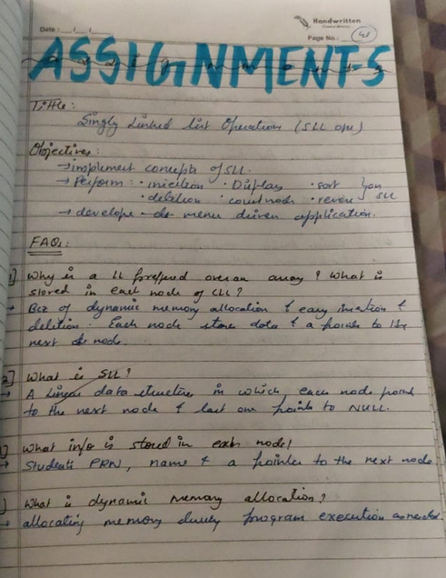
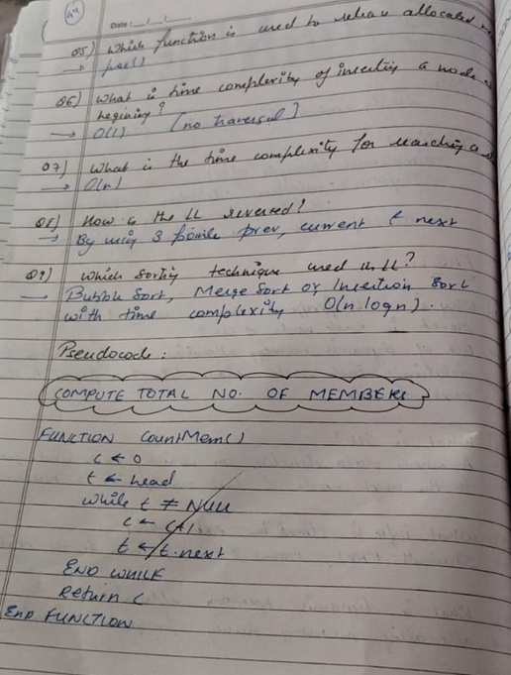
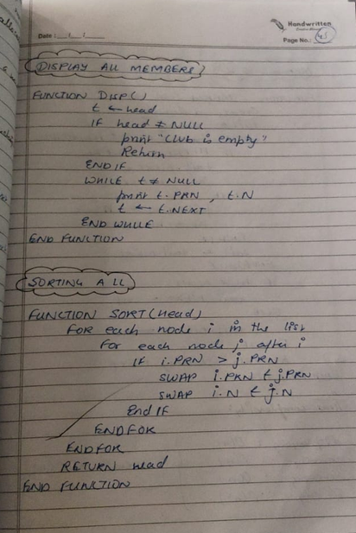
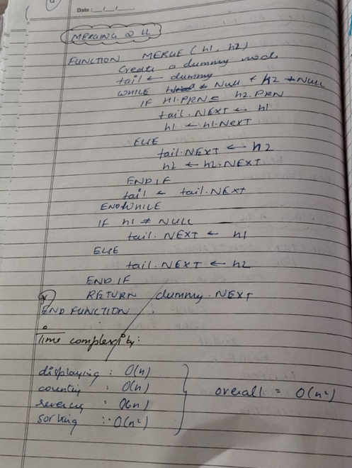
Code :
#
#include <stdio.h>
#include <stdlib.h>
#include <string.h>

struct Node {
int prn;
char name[50];
struct Node *next;
};

struct Node *head = NULL;

struct Node* createNode(int prn, char name[]) {
struct Node *newNode =
(struct Node*)malloc(sizeof(struct Node));

newNode->prn = prn;
strcpy(newNode->name, name);
newNode->next = NULL;

return newNode;
}

// Add president
void addPresident(int prn, char name[]) {
struct Node *newNode = createNode(prn, name);
newNode->next = head;
head = newNode;
}

// Add secretary
void addSecretary(int prn, char name[]) {
struct Node *newNode = createNode(prn, name);

if (head == NULL) {
head = newNode;
return;
}

struct Node *temp = head;

while (temp->next != NULL)
temp = temp->next;

temp->next = newNode;
}

// Add member before secretary
void addMember(int prn, char name[]) {
struct Node *newNode = createNode(prn, name);

if (head == NULL || head->next == NULL) {
printf("Add president and secretary first.\n");
free(newNode);
return;
}

struct Node *temp = head;

while (temp->next->next != NULL)
temp = temp->next;

newNode->next = temp->next;
temp->next = newNode;
}

// Delete president
void deletePresident() {
if (head == NULL) {
printf("Club is empty.\n");
return;
}

struct Node *temp = head;
head = head->next;
free(temp);
}

// Delete secretary
void deleteSecretary() {
if (head == NULL) {
printf("Club is empty.\n");
return;
}

if (head->next == NULL) {
free(head);
head = NULL;
return;
}

struct Node *temp = head;

while (temp->next->next != NULL)
temp = temp->next;

free(temp->next);
temp->next = NULL;
}

// Delete member using PRN
void deleteMember(int prn) {
struct Node *temp = head, *prev = NULL;

while (temp != NULL && temp->prn != prn) {
prev = temp;
temp = temp->next;
}

if (temp == NULL) {
printf("Member not found.\n");
return;
}

if (prev == NULL)
head = temp->next;
else
prev->next = temp->next;

free(temp);
printf("Member deleted.\n");
}

// Count members
int countMembers() {
int count = 0;
struct Node *temp = head;

while (temp != NULL) {
count++;
temp = temp->next;
}

return count;
}

// Display members
void display() {
struct Node *temp = head;

if (temp == NULL) {
printf("Club is empty.\n");
return;
}

printf("\nPRN\tName\n");

while (temp != NULL) {
printf("%d\t%s\n", temp->prn, temp->name);
temp = temp->next;
}
}

// Sort members by PRN
void sortList() {
struct Node *i, *j;
int prn;
char name[50];

for (i = head; i != NULL; i = i->next) {
for (j = i->next; j != NULL; j = j->next) {
if (i->prn > j->prn) {
prn = i->prn;
i->prn = j->prn;
j->prn = prn;

strcpy(name, i->name);
strcpy(i->name, j->name);
strcpy(j->name, name);
}
}
}

printf("List sorted by PRN.\n");
}

// Merge two lists
struct Node* mergeLists(struct Node *a, struct Node *b) {
if (a == NULL)
return b;

struct Node *temp = a;

while (temp->next != NULL)
temp = temp->next;

temp->next = b;
return a;
}

// Reverse list using pointers
void reverseList() {
struct Node *prev = NULL;
struct Node *curr = head;
struct Node *next = NULL;

while (curr != NULL) {
next = curr->next;
curr->next = prev;
prev = curr;
curr = next;
}

head = prev;
printf("List reversed.\n");
}

int main() {
int choice, prn;
char name[50];
struct Node *list2 = NULL;

do {
printf("\n--- PINNACLE CLUB ---\n");
printf("1. Add President\n");
printf("2. Add Member\n");
printf("3. Add Secretary\n");
printf("4. Delete President\n");
printf("5. Delete Member\n");
printf("6. Delete Secretary\n");
printf("7. Count Members\n");
printf("8. Display Members\n");
printf("9. Sort List\n");
printf("10. Merge with Second List\n");
printf("11. Reverse List\n");
printf("0. Exit\n");
printf("Enter choice: ");
scanf("%d", &choice);

switch (choice) {
case 1:
printf("Enter PRN and name: ");
scanf("%d %49s", &prn, name);
addPresident(prn, name);
break;

case 2:
printf("Enter PRN and name: ");
scanf("%d %49s", &prn, name);
addMember(prn, name);
break;

case 3:
printf("Enter PRN and name: ");
scanf("%d %49s", &prn, name);
addSecretary(prn, name);
break;

case 4:
deletePresident();
break;

case 5:
printf("Enter PRN to delete: ");
scanf("%d", &prn);
deleteMember(prn);
break;

case 6:
deleteSecretary();
break;

case 7:
printf("Total members: %d\n", countMembers());
break;

case 8:
display();
break;

case 9:
sortList();
break;

case 10:
printf("Enter second list member count: ");
int n;
scanf("%d", &n);

for (int k = 0; k < n; k++) {
printf("Enter PRN and name: ");
scanf("%d %49s", &prn, name);
addSecretary(prn, name);
}

list2 = NULL;
printf("Second list members added to the club list.\n");
break;

case 11:
reverseList();
break;

case 0:
printf("Exiting program.\n");
break;

default:
printf("Invalid choice.\n");
}
} while (choice != 0);

return 0;
}

Output :
--- PINNACLE CLUB ---
1. Add President
2. Add Member
3. Add Secretary
4. Delete President
5. Delete Member
6. Delete Secretary
7. Count Members
8. Display Members
9. Sort List
10. Merge with Second List
11. Reverse List
0. Exit
Enter choice: 1
Enter PRN and name: 101 Rahul

--- PINNACLE CLUB ---
Enter choice: 2
Enter PRN and name: 103 Amit

--- PINNACLE CLUB ---
Enter choice: 2
Enter PRN and name: 102 Priya

--- PINNACLE CLUB ---
Enter choice: 3
Enter PRN and name: 104 Sneha

--- PINNACLE CLUB ---
Enter choice: 8

PRN Name
101 Rahul
103 Amit
102 Priya
104 Sneha

--- PINNACLE CLUB ---
Enter choice: 7
Total members: 4

--- PINNACLE CLUB ---
Enter choice: 9
List sorted by PRN.

--- PINNACLE CLUB ---
Enter choice: 8

PRN Name
101 Rahul
102 Priya
103 Amit
104 Sneha

--- PINNACLE CLUB ---
Enter choice: 5
Enter PRN to delete: 102
Member deleted.

--- PINNACLE CLUB ---
Enter choice: 8

PRN Name
101 Rahul
103 Amit
104 Sneha

--- PINNACLE CLUB ---
Enter choice: 11
List reversed.

--- PINNACLE CLUB ---
Enter choice: 8

PRN Name
104 Sneha
103 Amit
101 Rahul

--- PINNACLE CLUB ---
Enter choice: 4

--- PINNACLE CLUB ---
Enter choice: 8

PRN Name
103 Amit
101 Rahul

--- PINNACLE CLUB ---
Enter choice: 6

--- PINNACLE CLUB ---
Enter choice: 8

PRN Name
103 Amit

--- PINNACLE CLUB ---
Enter choice: 7
Total members: 1

--- PINNACLE CLUB ---
Enter choice: 0
Exiting program.

